Hello, Everyone!

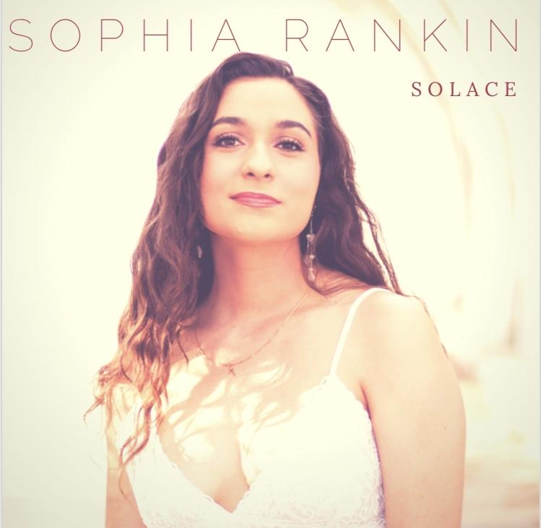
Welcome to your weekly source of information on my upcoming music video. I will be posting updates once a week so as to keep you involved in every step of the process and get you as excited as I am for the release of the video. I have chosen the song I want to record, and it is definitely a fan favorite off of my new album, SOLACE. I want to showcase this song because it highlights the nature of my genre of music in the best way, which is also the reason why I put it as the opening track of the album. Yes, the song we will be recording is “Go My Way” and it is going to be so incredibly fun. I am planning on incorporating my fiddle player, Will, in the video to showcase his solos on the song. This song is the best blend of folk and pop music that I have created on this album, and I am so proud of my ability to show off two styles of music that have shaped who I am and influence who I will become.
SOLACE (2018), available on iTunes, Apple Music, Spotify, and all other music platforms.
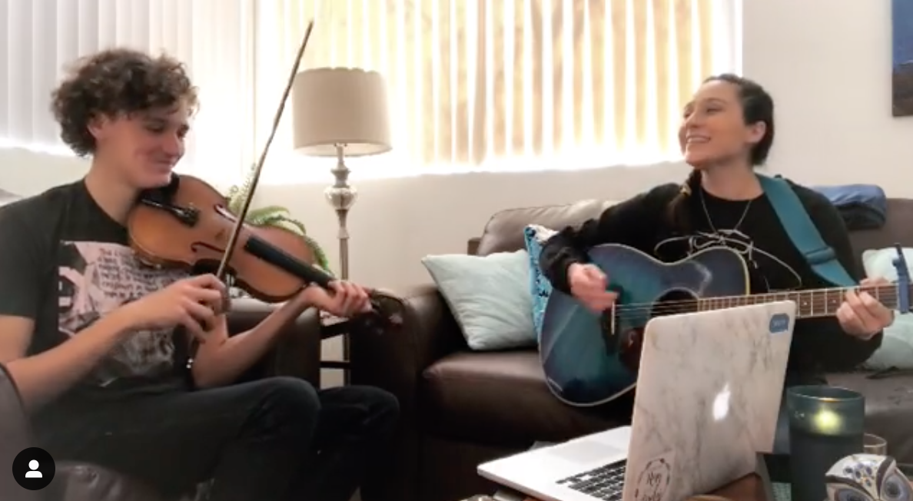
Will MacDonald, the fiddle player who performed on “Go My Way”
This first week of planning was spent picking the song for the video, choosing an ideal budget, and researching directors that would effectively deliver my vision for this song. I asked around through recording studios and friends to see who and what were recommended, and there were many options that appealed to me (especially budget-wise). However, many of them were inexperienced with either photography or videography in any form, or some were far too expensive for my budget. Having put so much effort and money into creating and releasing SOLACE I just could not afford to put too much into the video since I still am in college and have to afford textbooks. That being said, I did some deep searching and found an amazing photographer who had just begun shooting versions of music videos and posting them to his instagram. To my luck, he had gone to my high school and followed my back from years and years ago. The trick of the matter was that we had never actually had a conversation together in our time knowing each other, and were more acquaintances than friends. His work was incredible though, and I knew I had to simply try and see if he would take me on as a project. I reached out to him through personal messaging, and the rest was history. We decided on a budget fair to my pursestrings and respectful towards his craft and we have decided to meet soon to go over the details, storyboard, and to begin planning the video.
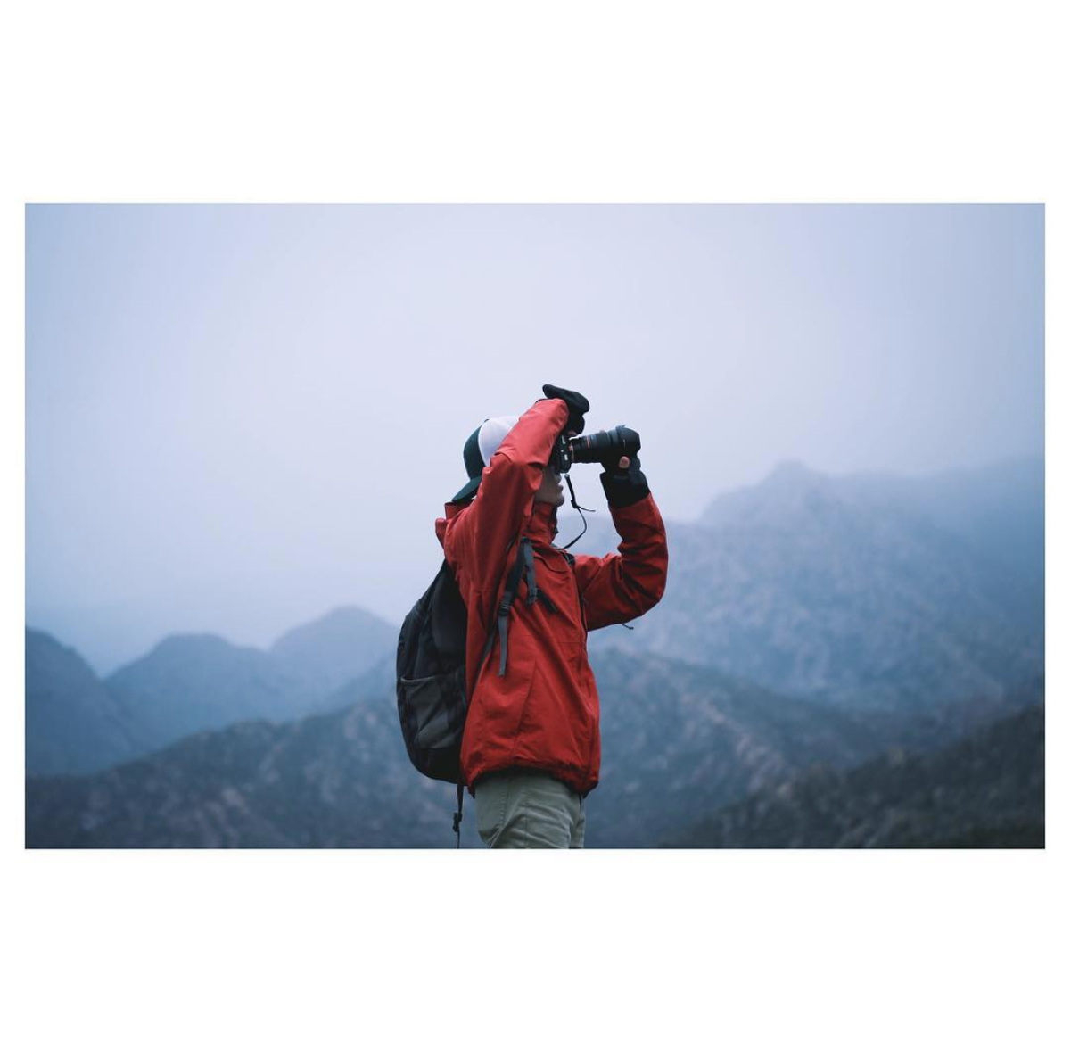
My future director/videographer is Addison Shinn, a professional photographer who is branching into music videos to further enhance his portfolio and resume. His style is natural and highlights the best aspects of his clients in both the physical and emotional sense. He keeps sessions friendly and comfortable and makes sure his clients are themselves and not an off-hand version in photos. I chose him because his photography style reminded me of my approach to music: I want to show off the best version of myself without sacrificing what makes me who I am, and his photos showed me that better than any other photographer I have seen. He embraces his clients in these shoots by capturing them in their most candid and honest moments to show his audience who they are with a single frame. When they say a picture is worth a thousand words, Addison’s work is the living proof.
A sample of Addison Shinn’s work. Courtesy of @addisonshinn
(more available on his instagram and website www.addisonshinn.com).

I have so much faith that this video will be incredible, and I cannot wait to keep you all posted on the process of it all as it happens. I hope to stay true to myself and my music, and to show off the song in the best way possible. Keep checking in on my website every Wednesday to see updates on the video and when it will be released.
All my love,
S

